Nama : Yoga Christian

NIM : 72220579

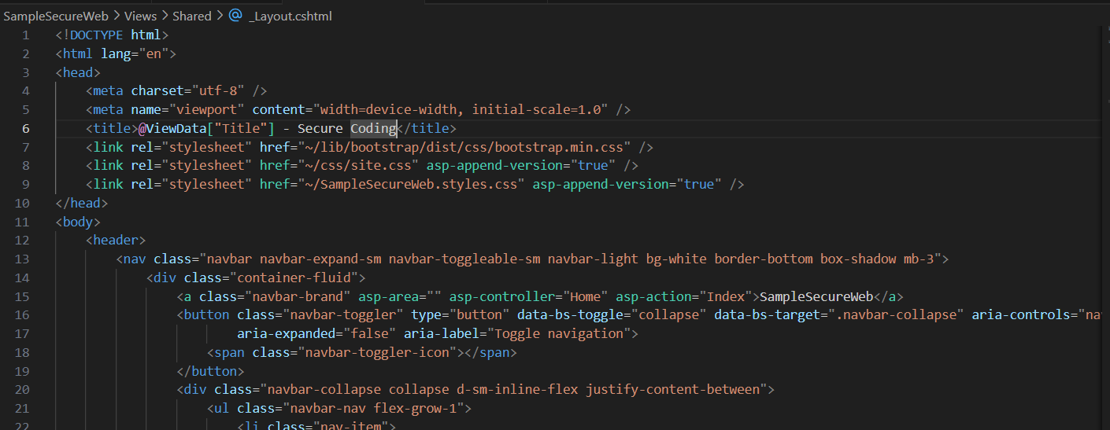

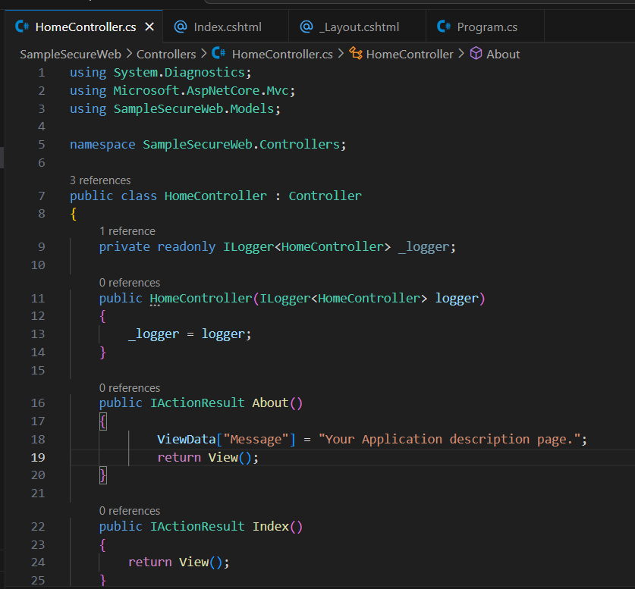

Microsoft,EntityFrameworkCore.Sqlite

Microsoft,EntityFrameworkCore.Design

Microsoft,EntityFrameworkCore.Tools



